**PRESEASON BOYS TOP 50 XC TEAMS 2019**

[**DyeStat.com**](https://www.dyestat.com/) August 24, 2019, 6:07am

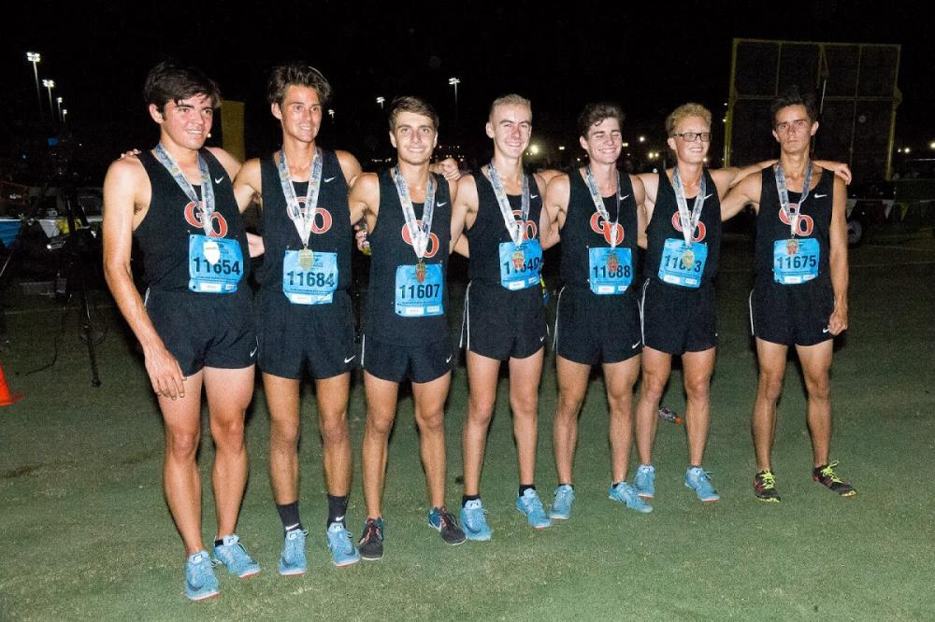

**Great Oak In Position To Knock Off Loudoun Valley**

**By Paul Schmitz of DyeStat**

Great Oak CA bumps Loudoun Valley VA from its two-year run as the No. 1 boys cross country team in the country. That's our prediction as the 2019 season begins.

The latest edition of the Wolfpack includes **Mateo Joseph**, **John Worthy**, **Chris Verdugo** and **Cole Sawires Yager**. The return of a healthy **Gabe Abbes** is the potential difference-maker that turns last year's No. 2 team at NXN into the preseason No. 1. Great Oak also added junior **Christian Simone** from Chaminade CA, in addition to having seniors **Leandro Candray**, **Aric Reza** and **Parker Smith** providing impressive depth for a group that also features one of the best freshman classes in program history.

The top tier of the rankings consists of six teams that all have a legitimate shot at the national title. Corner Canyon UT didn’t qualify for NXN in 2018, finishing fifth in the tough NXR Southwest. However the Chargers return all five of their top runners and welcome one of the elite runners in the country to their program, **Easton Allred**. Corner Canyon has the potential to win it all. The question mark about Allred’s health and the depth of the Great Oak lineup keep Corner Canyon at No. 2.

It is difficult to rank Loudoun Valley VA at No. 3 this year after watching the team's record-breaking performance at Portland last year. Loudoun Valley has been historically good the past two seasons. With solid returners **Kellen Hasle,** **Carlos Shultz**, **Mateo Barreto** and **Kevin Carlson** this is a team with the talent for a title. However, the top teams in the country are so good this year, Loudoun Valley will need one more high-quality runner to join the top five in order to take home a third title in a row.

If only four runners scored in cross country, the No. 3 through No. 6 teams on this list might replace the top three as podium picks. Newbury Park CA, Dakota Ridge CO and Fayetteville-Manlius NY all return proven, talented runners at the top but lack a knowable, projectable runner at No 5. Led by seniors **Nico Young** and **Jace Aschbrenner**, Newbury Park matches Corner Canyon UT (Easton Allred and Mark Boyle) with the fastest 1-2 punch in the country. NP will rely on four or five underclassmen to fill out their ranks and could move up from their sixth-place NXN finish in 2018 if the youngsters take a step forward.

Dakota Ridge is solid 1-4 with **Connor Ohlson**, **Jacob White**, **Ben Piegat** and **Benjamin Morrin**. The 2018 NXR SW champions and NXN third place finishers return the 2-5 runners from that team but lose top runner **Austin Vancil** and their six and seven to gradation and will need to fill a spot in order to return to the podium.

Fayetteville-Manlius is the team with the most volatility in the top six. Last year's NXR New York champion and NXN fifth-place finisher return three of five and four of seven. Those top four can run with any four in the country but it's tough to find a fifth runner ready to run at the elite level needed for FM to move up. Given the program's history, the emergence of a quality fifth runner is likely and **Bill Aris’** team could end with a record sixth podium finish. If that fifth spot stays where it is currently projected, FM will be pressed to match 2018. The Hornets (Stotans) are led by **Sam Otis**, **Geoff Howels** and **Peyton Geehrer**.

The Northwest is not represented in the top 10, but there are four teams in the region that all have the capability to move up by championship season. Jesuit OR, Kamiakin WA, Lewis and Clark WA and Tahoma WA all profile very close to each other.

**The Preseason Top 50**

1.    Great Oak CA

2.    Corner Canyon UT

3.    Loudoun Valley VA

4.    Newbury Park CA

5.    Dakota Ridge CO

6.    Fayetteville-Manlius NY

7.    York IL

8.    The Woodlands TX

9.    Wheaton Warrenville South IL

10.  Mountain Vista CO

11.  La Salle Academy RI

12.  Christian Brothers Academy NJ

13.  Bellarmine Prep CA

14.  Jesuit OR

15.  Bishop Hendricken RI

16.  Southlake Carroll TX

17.  Kamiakin WA

18.  Lewis and Clark WA

19.  El Paso Eastwood TX

20.  St. Charles IL

21.  Tahoma WA

***22.  Mounds View MN***

23.  Highland AZ

24.  Flower Mound TX

25.  Hersey IL

26.  Dublin CA

27.  Clovis North CA

28.  Middleton WI

29.  Dana Hills CA

30.  Haddonfield Memorial NJ

31.  Huntsville AL

32.  Cherokee NJ

33.  Davis UT

34.  La Costa Canyon CA

35.  Camas WA

36.  Belen Jesuit Prep FL

37.  Claremont CA

38.  Fort Collins CO

39.  Oswego East IL

40.  Tolland CT

41.  American Fork UT

42.  Dowling Catholic IA

43.  Western Albemarle VA

44.  Albuquerque Academy NM

45.  Lone Peak UT

46.  Poway CA

47.  Olympia WA

48.  Westfield NJ

49.  Fort Wayne Concordia Lutheran IN

50.  Franklin OR